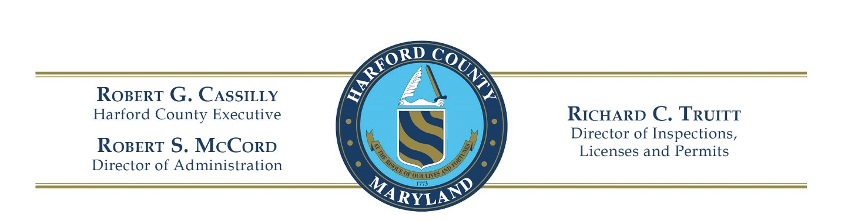

HARFORD COUNTY
BUILDING CODE BOARD OF APPEALS

Certified and Regular Mail January 10, 2025

Ms. Marlene L. Harvey
1903 Brookside Drive
Edgewood, MD 21040

RE: Appeal to Decision of Building Official
Case Record: DILPAPPEAL–000491-2024
Reference # 00391-2024
Order to Abate an Unsafe Condition

Dear Ms. Harvey:

The Harford County Building Code Board of Appeals convened on December 19, 2024, to hear your appeal of an Official Order rendered by Mr. Richard C. Truitt, Sr., Chief, Building Services Division, Department of Inspections, Licenses and Permits. Mr. Truitt’s Notice of Violation for the property located at 1903 Brookside Drive in Edgewood, Maryland, was recorded on November 26, 2024. The Board’s findings are as follows:

FINDINGS OF FACT

After opening testimony was heard, Mr. Truitt requested a short recess. The Appellants and County representatives met outside of chambers. The parties returned and offered a temporary settlement agreement to investigate and repair the purported sewage leak in 1903 Brookside Drive, Edgewood, Maryland. A period of Two (2) weeks was agreed.

DECISION

It is the Board’s belief that granting a stay for two weeks to correct the perceived plumbing problems at 1903 Brookside Drive, Edgewood, Maryland, is in the best interest of the concerned parties. A Motion was made, seconded, and unanimously adopted to permit a two-week reprieve in order for necessary plumbing repairs to be made. The Board has been informed that a plumbing permit was obtained on December 31, 2024, and repairs to the sewer line were made. A final inspection resulted in a notice of completion for the scope of the work. The Unsafe Structure case at 1903 Brookside Drive has therefore been closed by Mr. Truitt.

After speaking with the secretary to the Board, Mrs. Laura Keller, on January 9, 2025, you have agreed that there is no longer a need to move forward with reconvening to hear the appeal. You have the right to appeal the Board’s decision in a Court of Law. If that is your desire, please contact Mr. Ethan Clasing, Assistant County Attorney, Harford County Office of Law, or private counsel regarding that procedure.This concludes our comments. On behalf of the Board, we appreciate your patience. If you have any questions, please refer them to Mr. Joseph E. ("Ethan") Clasing, Assistant County Attorney.

Sincerely,

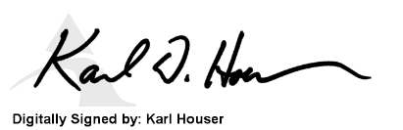

Karl D. Houser, P.E.
Chairman

cc: Mr. Joseph E. ("Ethan") Clasing, Esq., Harford County Office of Law
Mr. Timothy Marsheck, Esq., Harford County Office of Law
Mr. Richard Truitt, Sr., Dept. of Inspections, Licenses and Permits

