

FOR IMMEDIATE RELEASE

Dec. 11, 2023

For more information, contact:
Matt Button, Public Information Officer
410-638-3538
mbbutton@harfordcountymd.gov

VIDEO: Holiday Greetings from Harford County Executive Bob Cassilly

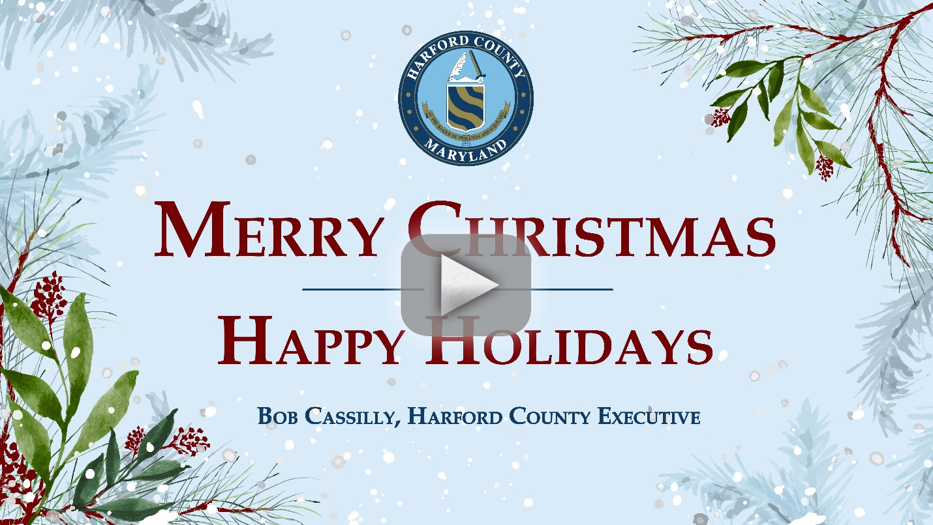

###
- Like us on Facebook https://www.facebook.com/HarfordCountyMD |
Follow us on Twitter @HarfordCountyMD
